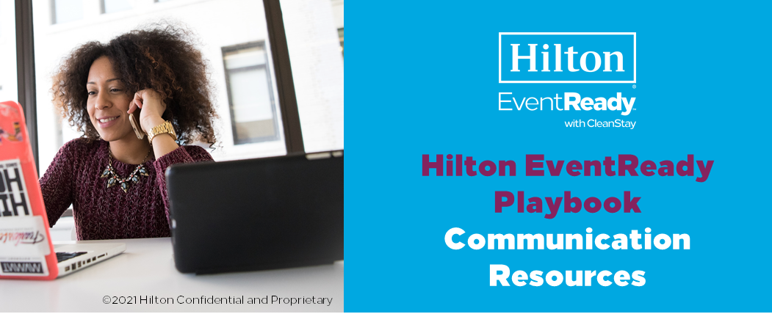
The Communications resources give you details about the event experience for your use when preparing materials for your attendees before, during and after your event.
Below you will find this content so you can easily build out your event communications to ensure your attendees are to ensure they have peace of mind throughout their entire journey. Simply copy and paste to build out your attendee communications.
Hilton CleanStay – what you need to know
Hilton CleanStay is an industry-leading program designed to deliver elevated standards of cleanliness, helping attendees enjoy an even cleaner and safer stay. Share with attendees what they can expect to see and experience with the following:
Online resources  Even before you depart, visit Hilton.com/cleanstay to learn more about our cleanliness program and what to expect during your stay. | The lobby experience  If you prefer a contactless arrival experience, download the free Hilton Honors mobile app onto your mobile device. Within the app, you can check-in, choose your room, check-out and even unlock your room door with Hilton Digital Key where available. This option is available at over 4,800 Hilton properties mainly in the US, UK, and Canada, with availability in other countries where local regulations allow. For those attendees who do not have access to the digital technology, physical distancing measures will be in place directing guests on how to move through the in-person check-in and check-out process in a safe way. | Coat check/ luggage/ bell service  Luggage and doorman services will vary by property, so please check availability with your event hotel team; carts will be available for self-service and will be sanitized after each use. Attended coat check service may be available based on the hotel. Otherwise, self-serve coat check will be available with sanitized coat hangers. | Food and beverage offerings  In hotel restaurants, as well as event spaces, tables and chairs will be spaced to ensure proper physical distancing based on local guidance. Biodegradable, disposable dishes and utensils will be available upon request. During breakfast, restaurants will offer a range of options, including grab & go, pre-plated covered items, à la carte and assisted service. When ordering room service, where provided, you will experience contactless delivery, with orders placed outside your guest room door. Please visit the hotel website for updates on the status of food and beverage service.

Hilton CleanStay – what you need to know (continued)
Housekeeping service options  Guest rooms will be thoroughly cleaned and disinfected between guests. The frequency of housekeeping services during a guest’s stay will be based upon guest preference, recognizing that some guests may not want staff entering their room. | The guest room differences  Your first point of contact with the guest room will be the Hilton CleanStay room seal, placed on the door upon being thoroughly cleaned. The room will have extra disinfection of the most frequently touched guest room areas – light switches, door handles, TV remotes, thermostats and more. | Elevator/escalator protocols  Hand sanitizing and disinfecting stations will be stationed at high traffic areas, such as near elevators and escalators. Additionally, you will notice that elevators are being cleaned more frequently. The number of guests permitted on elevators will be indicated with physical distancing signage and will vary based on local guidelines and size of elevator. | Face coverings/ gloves  Hilton Team Members will follow local guidelines regarding required use of face coverings, gloves and other protective equipment to ensure both a safe work environment and safe experience for our guests. Check with event hotel for local requirements and recommendations for face coverings. | Reimagined public spaces  There will be increased frequency of cleaning public areas. For instance, fitness centers may be closed for cleaning multiple times daily. Equipment will be properly adjusted and positioned to enable physical distancing and the number of guests in the center may be limited. Pool and pool areas will be cleaned frequently throughout the day and physical distancing measures will be in place based on local guidance. Stations with hand sanitizer and disinfecting wipes will be available throughout the property at primary entrances and in key high-traffic areas. Please visit the event hotel website or call the front desk for updates on the status of public spaces and amenities availability.

Hilton EventReady with CleanStay – what you need to know
Hilton EventReady with CleanStay is Hilton’s global meeting and events program designed to create event experiences that are clean, flexible, safe and socially responsible. You’ll likely take notice of the extra cleanliness protocols that will be in effect around the event spaces as well as socially responsible event solutions.
Extra disinfection efforts being put in place for the 10 most high-touch areas of the meeting room:  Tables, chairs, door pulls, thermostat and lighting controls, window shade and drape controls, room phones, stationary room furniture, podium and stage items, AV equipment, and sanitizing stations. | Creative physical  distant event sets  and meal service. | Inspiring food & beverage offerings. | Continued focus  on environmental  impact solutions.

Safety and security – what you need to know
Temperature  checks  Hilton is carefully monitoring guidance from local health officials that may require health and symptom checks for both Team Members and event attendees. Where required by law, Team Members, guests and event attendees must adhere to daily health and symptom self-screenings and/or temperature screenings before entering a hotel. | Physical distancing  regulation  You must comply with the physical distancing guidelines and restrictions in place for the local jurisdiction where the hotel is located. You’ll notice signage throughout the hotel that encourages physical distancing. | Face covering  requirements  Hilton will adhere to face covering requirements. | Physical distancing recommendations  The safety of guests and Hilton Team Members is Hilton’s number one priority. Hilton Team Members have been provided with specific training on how to manage new physical distancing requirements as travel resumes around the world. Team Members are also reminding guests at check-in to adhere to physical distancing so that both guests and Team Members can feel safe and comfortable while on property.

Hilton team member  COVID-19 education  Team Members are educated on the symptoms of COVID-19 and are prohibited from coming to work if they are ill or symptomatic. Hilton is carefully monitoring guidance from the World Health Organization (WHO), and regional authorities which may require health and symptom checks. Where required by law, Team Members must adhere to conducting daily health and symptom self-screenings and/or temperature screenings before entering a hotel or corporate office. | Attendee pre-arrival check list  To help your attendees prepare and plan for their upcoming trip and event, we have developed a simple checklist of helpful tips you can customize and send to your attendees 2-3 weeks before they depart. | Contact tracing  Currently our hotels do not participate in contact tracing.
Communications Resources:
Drive excitement before and maintain momentum after your events with the following tools. These materials can assist you and your attendees with understanding what to expect before, during and after your event.
Driving excitement before your event  Attendee pre-event email template  Click here  Pre-arrival checklist  Click here  Maintaining the momentum after the event  Attendee post-event email template  Click here  Suggested social media guidance  Click here | EventReady Resources  Planner journey infographic  (Americas/Europe, Middle East, and Africa):  Click here  Attendee journey infographic  (Americas/Europe, Middle East, and Africa):  Click here  Planner journey infographic (Asia Pacific):  Click here  Attendee journey infographic (Asia Pacific):  Click here  Event room infographic:  Click here

