[EVENT NAME]
LIVESTREAM
[Event Date]
IT Checklist
OBJECTIVE
The purpose of this document is to establish the scope and requirements for a livestream event. The below document should be reviewed with local IT support.
LIVESTREAM SCOPE AND TECHNOLOGY CONSIDERATIONS
REQUIREMENT | KEY CONSIDERATION | LOCATION 1 | LOCATION 2
Venue |  | Hybrid event sample | Hybrid event sample
Venue location |  | Hilton New York Midtown | Waldorf Astoria Shanghai
On-site attendees |  | 50 | 50
Remote attendees | Share tips & tricks for best viewing experience | 5,000 | 5000
Property contact
Livestream coordinator
Hotel IT contact
AV contact
Bandwidth requirement for event | Production partner should be able to provide estimate | 100 MB | 30 MB
Combined hotel/event bandwidth requirement |  | 200 MB | 80 MB
Event space internet circuit Provider |  | AT&T | China Telecom
Internet bandwidth on WAN circuit |  | 250MB | 80-100mbps ISP + Switch (with charges)
Average peak utilization on circuit |  | 80 MB | 80 MB
Is this circuit dedicated to the event space only or is it also handling traffic to/from the Guest Network? |  | Guest and event space is on this AT&T circuit | Event room network
Power supply & backup |  | No power back: generator only for lights | Renting generator

Completed by: ___________________________________________ Date completed:______________

Sample Bandwidth Report:
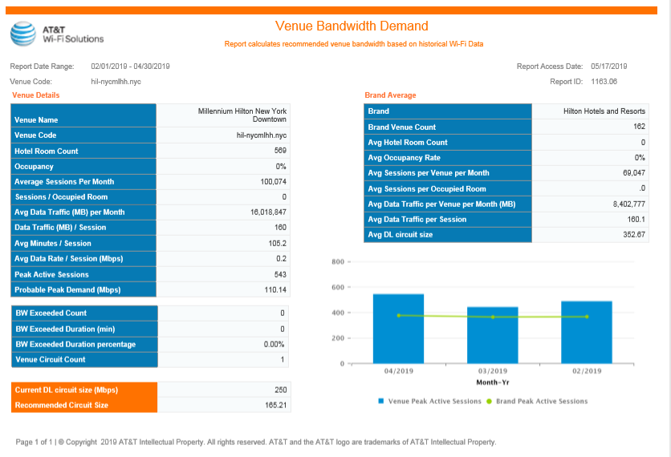

Other Resources:
Suggested Language for SOW:
- Vendor will work with local technology to complete requirements (IT Checklist).
- Vendor will work with local IT support to deliver a testing and fail over plan. For larger or complex events, testing will be performed onsite.
- For larger or complex events, tech partner agrees to complete Hilton provided contingency/communication plan.

Contingency Plan (Previously Provided)

